Magno Charge: An Intelligent Auto Disconnect Charger
Dr. G. Chamundeswari, P. Giridhar, Ch. Dileep Kumar Reddy, V. Akash, K. Vishnu Vardhan Reddy
Ramachandra College of Engineering, Eluru District, Andhra Pradesh, India
drgantachamu@rcee.ac.in, giridharpedda@gmail.com, challa.dileepkumarreddy@gmail.com, akashveerla0@gmail.com, emailme.vishnuzoro@gmail.com

Abstract
Magno Charge introduces a revolutionary charging solution that addresses the pervasive issue of trickle charging in mobile devices, enhancing safety, energy efficiency, and battery longevity. By leveraging cutting-edge Electromagnetic properties and seamless wireless communication, this system ensures automatic physical disconnection of the charging cable upon reaching the preset battery level. Magno Charge is a pioneering and user-centric alternative to conventional charging technologies.
Keywords: Trickle Charging, Battery safety, Automatic Physical Disconnection, User-centric Design
I. Background
Mobile phones have become an indispensable part of modern life, making safe and efficient charging practices essential. Conventional charging systems, however lack mechanisms to completely halt charging once the device reaches full capacity. While most modern smartphones and battery powered devices discontinues the charging animation to indicate that the device is not being charged. The device typically remains connected to the power source. In this state, the phone or any other device continues to consume small amounts of power for background operations. The battery subsequently gets topped up to maintain its full charge level.
This process is known as trickle charging or top-off charging, wherein the battery undergoes repeated cycles of minor discharging and recharging while still connected to the charger. Although this mechanism ensures the battery remains maximum capacity, it introduces several drawbacks when applied to lithium-ion batteries such as:
- Accelerated Degradation
- Increased Heat Generation
- Capacity Loss Overtime
- Safety Concerns and Inefficiency
In order to solve these problems, Magno Charge has a magnetic mechanism that the makes the charging cable to be separated from the device after it’s battery reaches a preset level which improves the battery life overtime.
II. Problem Statement
Conventional charging systems often allow devices to remain connected to power even after reaching a full charge, leading to a phenomenon known as trickle charging. This continuous power flow, even in small amounts, can cause several issues like battery degradation and thermal stress etc. Some chargers use electronic switching components like relays or MOSFETs, which only partially terminate the power flow and can still lead to residual power consumption. The below picture gives you a better idea about the concept of trickle charging.
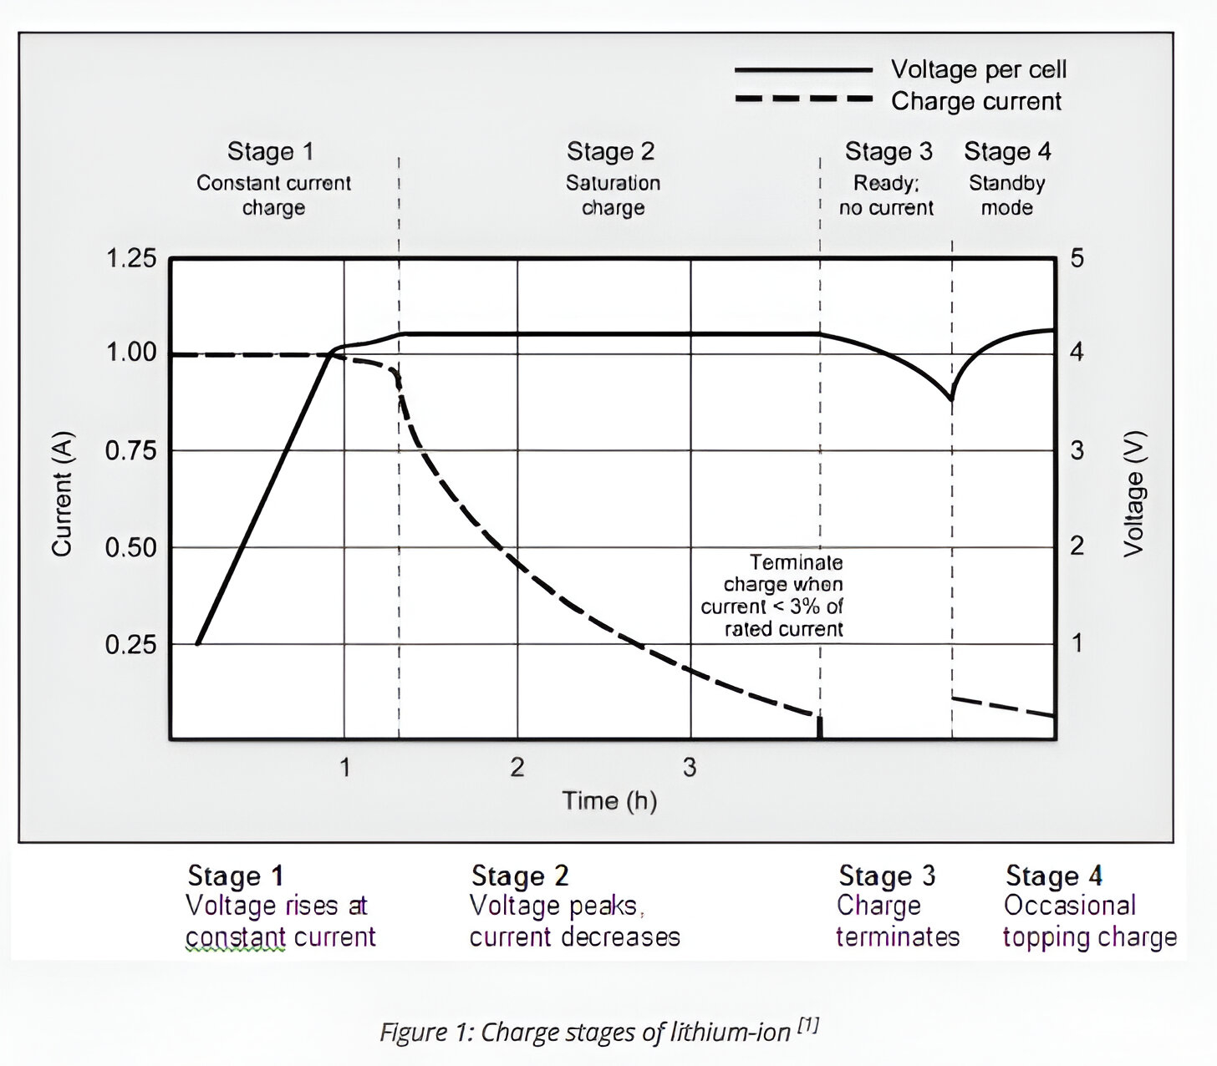
Figure 1 illustrates the charge stages of a typical lithium-ion battery, detailing the behaviour of both voltage and current throughout the process.
Stage 1: During this preliminary stage, the charger delivers a steady current to the battery. With a stable current, the voltage per cell increases linearly over time. This phase is essential for rapidly replenishing a substantial fraction of the battery's charge.
Stage 2: Upon reaching its maximal voltage, the system enters a saturation phase. The charger sustains a stable voltage, whereas the charging current commences an exponential decline. This phase facilitates a gradual, more accurate charging of the residual capacity. Charging ceases when the current falls below a specified threshold, usually less than 3% of the rated current.
Stage 3: Upon meeting the termination requirements in Stage 2, the charging process is suspended, and the current flow terminates. The battery is now deemed completely charged and prepared for utilization.
Stage 4: Upon achieving a full charge, the gadget transitions into standby mode if it remains attached to the charger. During this phase, the charger delivers intermittent "topping charges" to restore the little energy depletion caused by self-discharge or limited device power consumption. The ongoing topping-off constitutes a form of trickle charging, which, as indicated in the document you gave, is a significant issue that might result in battery degeneration.
III. Objectives
- Automatic Disconnection: This is the core idea behind Magno Charge, which should design and develop a charging system that automatically disconnects when it reaches a preset threshold charge. That way, intervention is not needed, and optimal battery health is ensured as well as minimum energy wastage.
- Battery Protection and Longevity: One of the major reasons for battery degradation Is trickle charging, which shortens the general life of portable electronics. Magno Charge would avoid this problem through a smart cut-off mechanism that would prevent small amount of power input, keeping the batteries fresh and in use longer.
- User Convenience and Automation: Traditional chargers require users to manually disconnect the power source when charging is done. However, a lot of people forget to do so, leading to overcharging-related issues. Magno Charge automates the process; it provides the user with hassle-free charging which increases user satisfaction and safety in devices
- Customizable Charging Options: Different users have different charging requirements based on device type and the usage patterns. Magno Charge gives an option to customize the charging threshold wherein users can set predefined battery levels at which the charger auto-disconnects

Through these objectives, Magno Charge stands out as a revolutionary innovation that transforms the charging of a mobile through the safe, efficient, and user-friendly way it's conducted. Automation, smart technology, and energy efficiency intertwine in this advancement to present the future development in power management and consumer electronics.

IV. Literature Review
Current charging technologies focus much on fast charging or wireless charging, without attention to the serious problem of trickle charging. Trickle charging is well-documented and is known to contribute to loss of battery life and efficiency as well as pose some safety concerns. Many of today's charging solutions have taken the focus away from the smarter disconnection, which stops excessive flow of small packets of power after the battery reaches its full capacity.

Magno Charge addresses these shortcomings by integrating state-of-the-art smart charging technology with combining the properties of electromagnets. Unlike conventional chargers, it actively monitors battery levels and autonomously disconnects the power supply once the battery reaches a preset threshold level. This approach not only ensures enhanced battery safety and longevity but also improves energy efficiency by preventing unnecessary power usage. In addition, Magno Charge has wireless monitoring, making it possible to track the charge level and allow users to choose the threshold on disconnection with a smartphone application, thus raising the level of user control and ease.

By doing this, the Magno Charge bridges the technological gap while establishing itself in the charging technology landscape as holistic and forward-thinking, combining innovation and practicality into one solution that frees users from worries about overcharge-related issues. With the upsurge demand for sustainable, efficient energy, Magno Charge marks one of the advanced breakthroughs into the smart charging world. Some appliances include basic safety components but do not provide more comprehensive features such as auto-disconnecting. This greatly raises the risk issues associated with faster-than-average battery life consumption, ineffective use of energy, and even probable hazards.
On its part, Magno Charge mitigates these weaknesses with a combination of electromagnetic controlled, state-of-the-art, smart charging. This innovative approach does not only provide increased battery safety and life but also improves user experience through the automated disconnection process. Magno Charge thus bridges the technological gap as a comprehensive, forward-thinking solution in the landscape of charging technology.
V. Proposed System
MagnoCharge modifies traditional mobile chargers by introducing an intelligent auto-disconnection system. This innovation addresses issues like trickle charging and battery degradation by ensuring a complete physical separation of the power source from the device. The system consists of three main components: a modified charger adapter, a re-engineered USB cable, and a mobile software application.
Modified Charger Adapter and Software
A standard charger adapter is modified with a microcontroller and with a Bluetooth module for wireless communication. This enables the charger to obtain real-time data and control signals from the device undergoing charging. The user must install a certain software application on their mobile device, enabling them to establish a custom charge threshold for automatic disconnection. The application continuously observes the battery level and, when reaching the predetermined threshold, transmits a signal to the charger.

Re-engineered USB Cable and Electromagnet
The physical disconnection is made possible by a re-engineered USB cable that is familiar in appearance to existing magnetic charging cables. The cable’s female USB port, which normally uses four pins (VCC, GND, D+, and D-), is reconfigured for the MagnoCharge system. While the VCC and GND pins continue to supply power to the device, the D+ and D- pins are repurposed. Instead of being used for data exchange, these lines now provide power to a miniature electromagnet located at the end of the cable near the charging pin.
The charging pin connector, which sits in the device's charging port, is made of a material that is attracted to a magnet.
Overall Charging and Disconnection Process
The charging process begins when the user connects the cable to their device. The electromagnet, powered by the D+ and D- pins, activates and securely holds the charging pin in the port via magnetic attraction. The device's software then continuously monitors the battery's charge level.
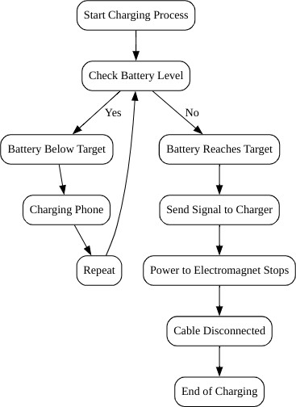
When the battery reaches the predefined threshold, the app sends a signal to the charger's microcontroller. The microcontroller then cuts the power to the electromagnet, causing the magnetic attraction to cease. The charging pin is automatically released from the device's port, physically severing the connection. This mechanical separation ensures a complete and reliable termination of the power flow, which is a significant improvement over electronic switching methods that can still lead to residual power consumption.

VI. Prototype in Action
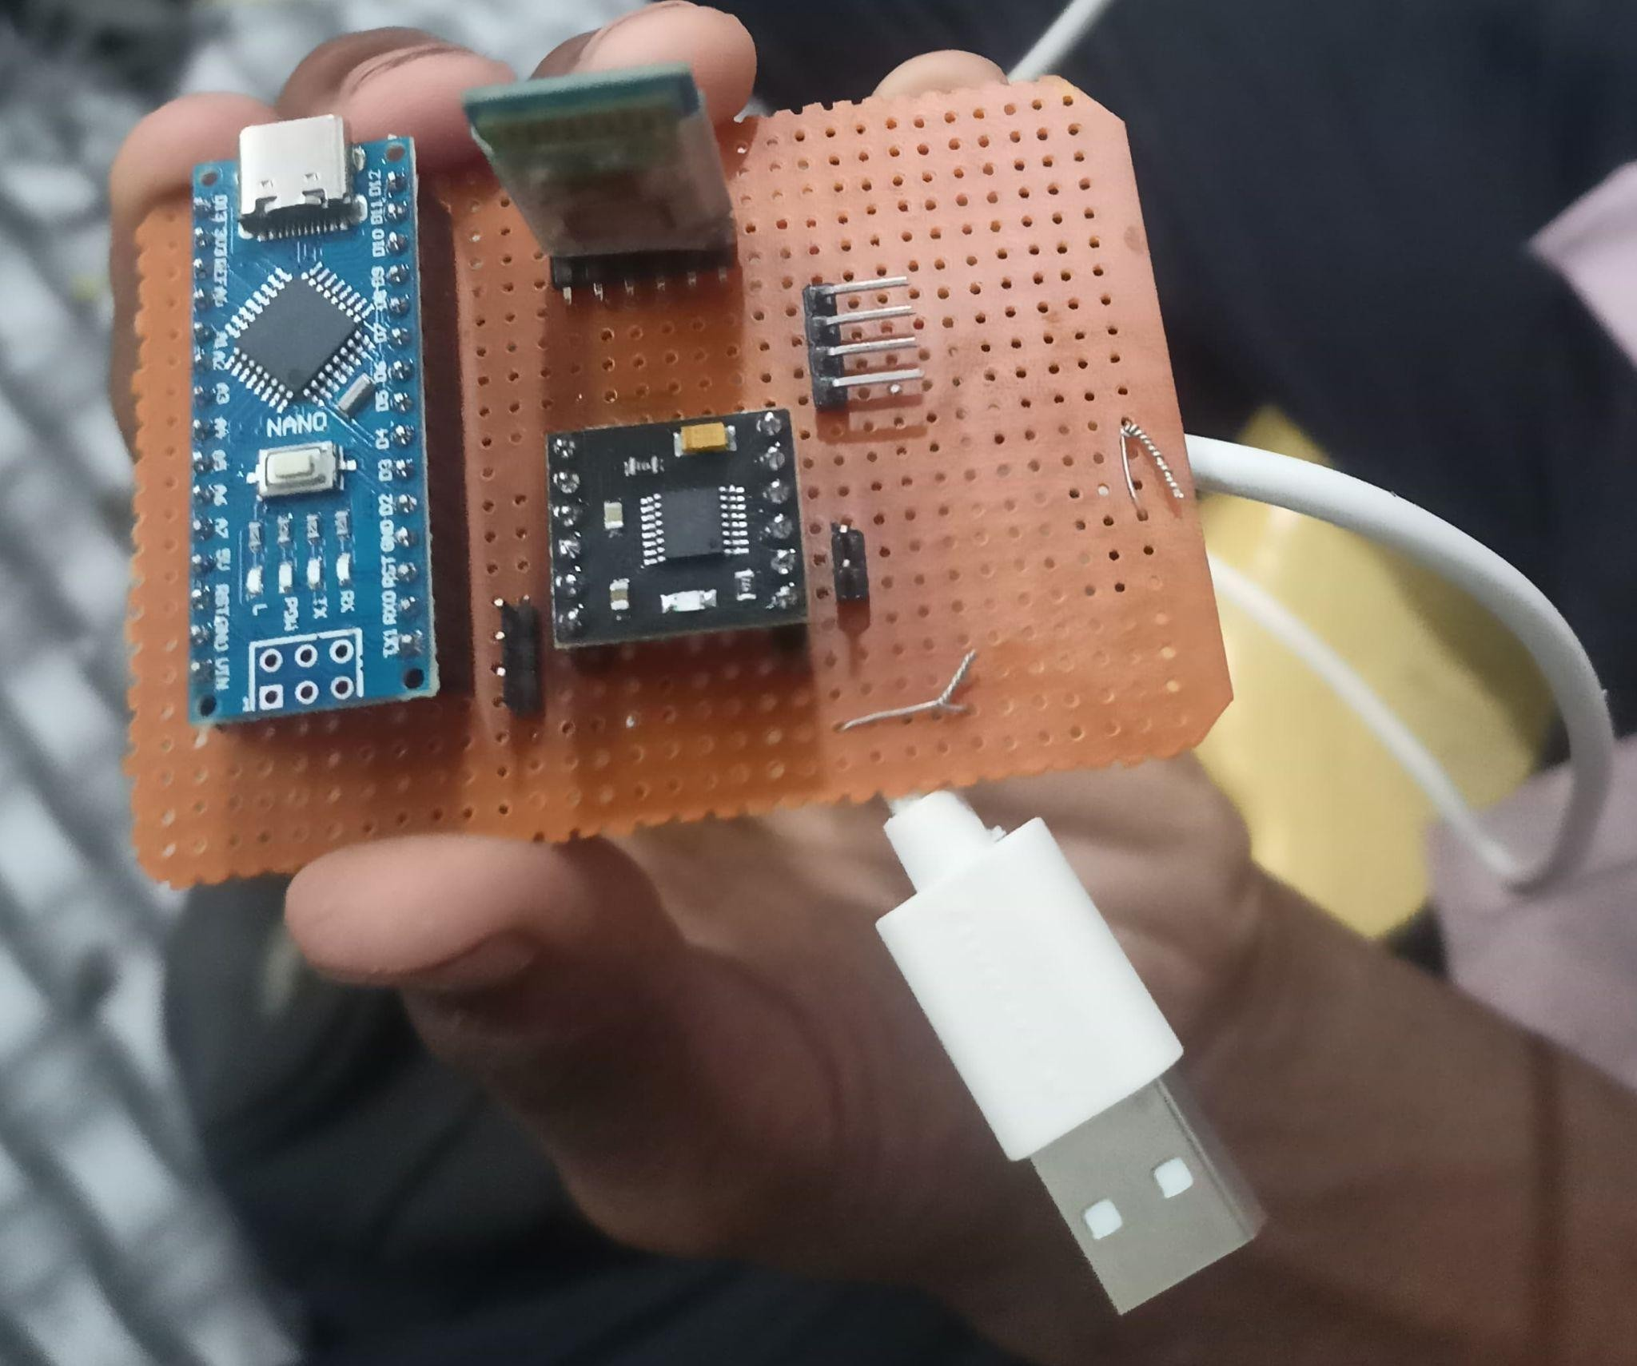
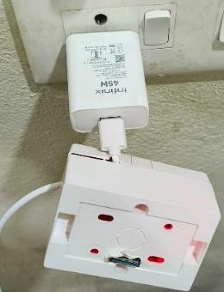
Our study explores the design and implementation of a prototype that autonomously terminates charging upon reaching a predefined battery level. At the core of this system is a microcontroller-based junction box that regulates power flow from a conventional mobile charger adapter.

The prototype incorporated a microcontroller-based control unit, a Bluetooth module for wireless communication, a solenoid actuator, and a magnetic connector integrated into a USB Type-C charging cable. A metallic flap mechanism enabled controlled detachment upon receiving a signal from the microcontroller. The system was powered using a standard USB power source to ensure compatibility with existing smartphones without requiring modifications to their hardware.
An external Adapter converts AC mains power into DC, which is then supplied to the junction box, integrating an Arduino Nano, a Bluetooth communication module, and an amplifier. This configuration enables precise control and real-time monitoring of the charging process.
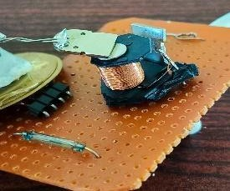
A custom-fabricated circuit board within the system houses a solenoid actuator essential for the physical disconnection mechanism. The system employs a metallic flap as the primary switching element, positioned on a stand that ensures clear visibility of the disconnection process. The stand itself incorporates conductor plates to facilitate electrical continuity.

The operational workflow is structured around a mobile application that allows users to set a predefined charge threshold. The smartphone application continuously tracks the device’s battery percentage periodically. We have developed a small application using platforms like MIT App Inventor as it supports development in less time. The user needs to enable Bluetooth on the device. After entering into the application, the user needs to enter the threshold level for which the cable should be disconnected physically. The threshold level must be greater than the current battery level and less than or equal to 100. The application periodically monitors the battery level. When the battery is charged up to the preset level then the application sends a disconnection signal to the Bluetooth module in the junction box. The microcontroller in the junction processes that signal and stops power to the electromagnet coil. With no power, the solenoid loses its magnetic property and releases the metallic flap which stops the power supply to the mobile or other targeted device.
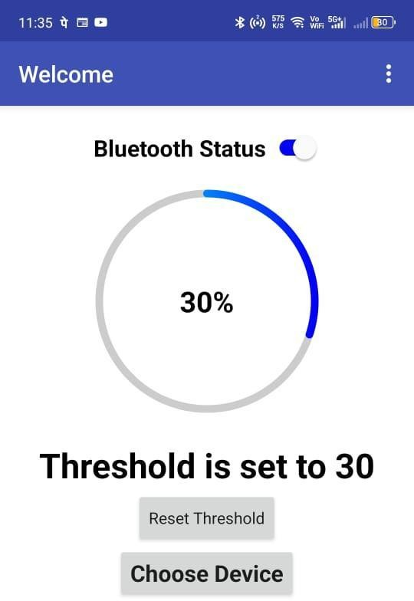
While the charge level remains below the preset limit, the solenoid remains engaged, maintaining current flow through the conductor plates and into the charging cable. Once the threshold is reached, the microcontroller deactivates the solenoid, disengaging the metallic flap and severing the power supply.
Experimental validation of the prototype confirmed the system’s ability to automate the charging disconnection process with high accuracy. Real-time monitoring through the mobile interface enhances user control while preventing overcharging, thereby contributing to improved battery lifespan. Future research will focus on refining solenoid response time, reducing latency in Bluetooth communication, and expanding compatibility with diverse smart devices.
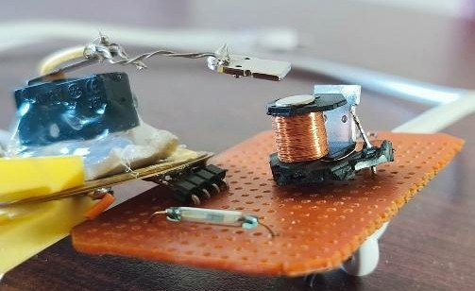
The charging process was monitored in real-time through a custom mobile application that communicated with the microcontroller over Bluetooth. The application allowed users to set a predefined battery threshold, upon reaching which the system would trigger the solenoid to disengage the magnetic connector. The microcontroller periodically retrieved battery status updates, ensuring minimal power consumption while maintaining a continuous monitoring cycle. Upon reaching the defined charge limit, the system successfully executed the disconnection process, effectively demonstrating its capability to halt charging without user intervention.
Observations from multiple trials confirmed that the system reliably detected battery levels and responded accordingly. The detachment mechanism operated smoothly, ensuring that the magnetic connector disengaged as intended when the trigger signal was received.
VII. How MagnoCharge Works in Real Life
First Time setup
The first configuration of the MagnoCharge system is a singular procedure intended to create a secure and dependable connection between the charger and the mobile device. The process commences when the user connects the adapter to a wall socket, thereby activating the internal microcontroller and the Bluetooth module. Initially, the user must manually pair their mobile device with the charger using Bluetooth. This essential measure creates a secure communication channel for all subsequent exchanges. Upon successful completion of the pairing, the electromagnet within the cable is activated. The user can subsequently insert the charging pin into the charging port of their mobile device. With the electromagnet activated, the charging pin is firmly secured by magnetic attraction, initiating the charging process. The user must concurrently launch the associated software application for the initial time. The application will prompt the user to establish a default disconnection threshold and solicit requisite rights, including the capability to ascertain when the device is connected to a power source. The application additionally establishes an event listener, enabling it to receive notifications on critical charging events and such as when the power source is connected, such as the connection of power.
Subsequent Use
Subsequent to the initial configuration, the procedure is optimized for user convenience, obviating the necessity for manual pairing or application setup for each use. Upon connecting the adapter to a wall socket, the Bluetooth module activates instantly and establishes a connection with the mobile device once it is within proximity. The electromagnet thereafter activates autonomously, enabling the user to effortlessly affix the charging pin to the mobile device's charging port, so ensuring a secure magnetic connection. The system provides two methods for managing the charging threshold. By default, a background service in the application will employ the threshold value established at the time of first registration. Upon reaching this battery level, the service will autonomously transmit a signal to the charger, initiating the physical disconnection. The user may alternatively open the app to manually set a one-time threshold for a particular charging session. This dual-mode capability maintains a balance between automation and user control, addressing various charging requirements.
Support for Charging Protocols
Different charging protocols like Power Delivery (PD), Quick Charge, and others rely on communication between the charger adapter and the mobile device. This communication happens through the D+ and D- lines, which are traditionally used for data exchange in a standard USB cable. The charger and the mobile device use these lines to exchange information and recognize if they are compatible with each other before a specific fast-charging protocol can be initiated.
In contrast, the MagnoCharge system modifies the functionality of these lines, repurposing them to power the miniature electromagnet for its unique physical disconnection mechanism. Since protocols require communication between charger and mobile we can use the established Bluetooth connection between charger and mobile to make support for protocol communication.
In protocols such as USB-PD or Quick Charge, the D+ and D- lines facilitate a "handshake" procedure. The device and charger transmit data packets to negotiate the appropriate voltage and current for optimal charging. This occurs nearly immediately upon connecting the device.
Employing a Bluetooth connection for this handshake transitions the communication from a physical cable to a wireless medium. This would let a charging station or adapter to interact with a mobile device to confirm compatibility, establish parameters, and oversee the charging session without depending on the physical data pins. This is a prevalent method in contemporary IoT charging stations for electric automobiles and other devices, facilitating features like as user authentication, remote monitoring, and firmware updates.
VIII. Conclusion
Magno Charge is an innovative, practical solution to a common problem with mobile devices related to overcharging. Integration of magnetic polarity control, wireless monitoring, and automatic disconnection enhances the longevity of a battery, reduces energy waste, and improves user convenience. Experimental results have confirmed its effectiveness in preventing overcharging, ensuring thermal safety, and promoting energy efficiency. The appeal of Magno Charge lies in its commercial adoption, marking a milestone in smarter charging technology. It boasts a reliable and sustainable method of managing power.
The adoption of the Magno Charge can also support overall global sustainability because of a decrease in electronic waste and energy consumption. The systems designed ensure that batteries last longer and remain efficient, decreasing their rates of replacement, therefore reducing negative environmental impact. Additionally, seamless integration with smart devices and a user-friendly interface makes it a viable solution for both individual consumers and large-scale applications, such as electric vehicles and industrial battery systems. As the demand for efficient and intelligent power management solutions continues to grow, Magno Charge is poised to become an essential component of next-generation charging technology. The system improves battery longevity, reduces energy waste, and increases user convenience through the integration of magnetic polarity control, wireless monitoring, and automatic disconnection. Experimental results have proven its effectiveness in preventing overcharging, ensuring thermal safety, and promoting energy efficiency. Strong potential for commercial adoption makes Magno Charge a significant advancement in smart charging technology, offering a reliable and sustainable approach to power management.

IX. References
Thermal Safety of Degraded Li‐Ion Batteries. International Journal of Energy Research, 2023(1), 8571535.
Fujita, Y., Hirose, Y., Kato, Y. and Watanabe, T., 2016. Development of battery management system. Fujitsu Ten Tech. J, 42(42), pp.68-80.

Pramanik, Pijush Kanti Dutta, et al. "Power consumption analysis, measurement, management, and issues: A state-of-the-art review of smartphone battery and energy usage." ieee Access 7 (2019): 182113-182172.

Manoharan, S., et al. "A Review on Smartphone Charger: Technologies and Challenges." 2024 5th International Conference on Intelligent Communication Technologies and Virtual Mobile Networks (ICICV). IEEE, 2024.

Devanhalli, Sanket Rajendra, H. S. Wagh, and Pritesh Kantilal Vasani. "Study of auto cut off electricity power supply on full charge of battery using microcontroller." International Journal of Innovative Research in Technology 6 (2020): 12.

Mankowski, P. J., Kanevsky, J., Bakirtzian, P., & Cugno, S. (2016). Cellular phone collateral damage: A review of burns associated with lithium battery powered mobile devices. Burns, 42(4), e61-e64.

Pramanik, P. K. D., Sinhababu, N., Mukherjee, B., Padmanaban, S., Maity, A., Upadhyaya, B. K., ... & Choudhury, P. (2019). Power consumption analysis, measurement, management, and issues: A state-of-the-art review of smartphone battery and energy usage. ieee Access, 7, 182113-182172.

Nair, Karan, et al. "Optimizing power consumption in iot based wireless sensor networks using Bluetooth Low Energy." 2015 International Conference on Green Computing and Internet of Things (ICGCIoT). IEEE, 2015.

Pröbstl, Alma, et al. "Smart2: Smart charging for smart phones." 2015 IEEE 21st International Conference on Embedded and Real-Time Computing Systems and Applications. IEEE, 2015.

Thompson, Silvanus Phillips. The electromagnet and electromagnetic mechanism.
E. & FN Spon, 1891.

Kale, Miss Snehal, and Bhoopesh N. Chaudhari. "IoT based battery monitoring system." 2022 international conference on advances in computing, communication and materials (ICACCM). IEEE, 2022.
Hoque, M. A., Siekkinen, M., Koo, J., & Tarkoma, S. (2017). Full charge capacity and charging diagnosis of smartphone batteries. IEEE Transactions on Mobile Computing, 16(11), 3042-3055.

